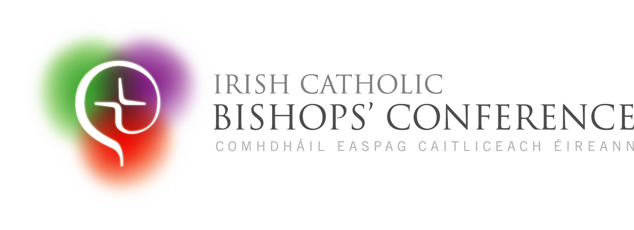

Pastoral Letter

**A Hundred Thousand Welcomes?**

Exploring what hospitality for migrant people means in contemporary Ireland

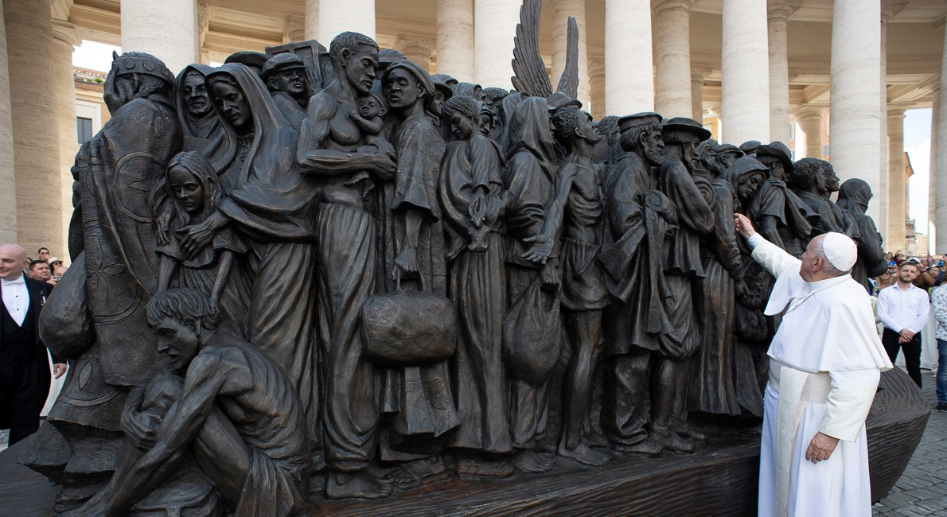ppp

**Hospitality in Today’s Ireland**

Ireland’s tradition of hospitality - céad míle fáilte - faces challenges due to rising immigration, which has exposed longstanding societal issues like housing, homelessness, and gaps in social services. These challenges existed before immigration became a prominent issue, but some fearful and angry voices now call for closing borders. However, the Irish people, conscious of our own history of migration and Christian faith, must continue to welcome newcomers. Many immigrants bring valuable skills and talents, while others seek support for a better future.

As Christians, the belief in the sanctity of life and the commandment to ‘love your neighbour’ calls us to care for everyone, regardless of their background. The parable of the Good Samaritan reminds us that our neighbour includes all, regardless of ethnicity or status. The Irish Catholic Bishops’ Conference urges all Christians, and people of goodwill, to embrace this Biblical invitation to welcome the stranger, creating parishes and communities of hospitality where people truly belong. Welcoming others is not only a societal duty but also a Gospel command to love and serve as Christ did.

***Reflect: When have you been blessed by hospitality that you received?***

**Migration: An Irish Reality**

Migration has been a central part of Irish history, shaped by events such as war, famine, economic collapse, and now, climate change. During the Great Famine (1845 - 1852), nearly two million people left Ireland, but migration has long been a reality for the Irish, with significant exoduses as recently as the 1950s and 1980s - the legacies of which remain with us today. It is a new experience for Ireland to be a destination for migrants, a clear sign of the country’s economic and social progress.

Historically, Irish migrants often faced discrimination abroad. Father Gerry McFlynn, of the Irish Council for Prisoners Overseas office in London, recalls the change since migrating to live in England at the end of the 1970’s. The 1980’s and 1990’s were difficult decades to be Irish there. ‘One had the strong sense of being “a suspect community”, having to keep one’s head down, say little publicly, always conscious of one’s accent and background.’ He adds that it was not until the *Good Friday Agreement* of 1998 that attitudes began to change for the better.

The Catholic faith itself is a migrant’s faith, spread throughout Ireland by Saint Patrick, an immigrant and former slave. The Irish diaspora played a key role in spreading the faith, with Irish missionaries and communities flourishing globally. Pope Francis, the son of immigrants, constantly highlights the sacredness of the migrant’s journey, reminding us that welcoming migrants is akin to welcoming Christ.

***Reflect: Have you or your loved ones been migrants? How did that experience feel?***

**Welcome: The Migrant’s Gift**

In recent years, Ireland has seen many immigrants seeking a better life, and local parishes, schools, and community organisations have played a key role in integrating them. The Catholic Church in Ireland has become a space where long established communities encounter and befriend newcomers, fostering diversity - which is a gift and a source of renewal.

One story relates to Irene Nunes, who came from Brazil to Ballyhaunis, Co Mayo, thirteen years ago. Irene and her family were warmly welcomed by the local parish, where she now serves as a sacristan and member of the Parish Pastoral Council. Irene speaks of the strong sense of belonging and community that she and other Brazilians have experienced in the parish. A beautiful example of this belonging was the recent celebration of marriage of five Brazilian couples, during the same ceremony, in Saint Patrick’s Church, Ballyhaunis. This experience of radical hospitality reflects early Christian communities, where cultural and ethnic divisions were overcome through shared faith in Jesus. The Church in Ireland now experiences this same sense of welcome and renewal through the presence of immigrants.

**Caption** Five Brazilian couples who were married in May 2024 by Deacon Rev Wando Araujo, in Saint Patrick’s Church, Ballyhaunis, Co Mayo, Archdiocese of Tuam.

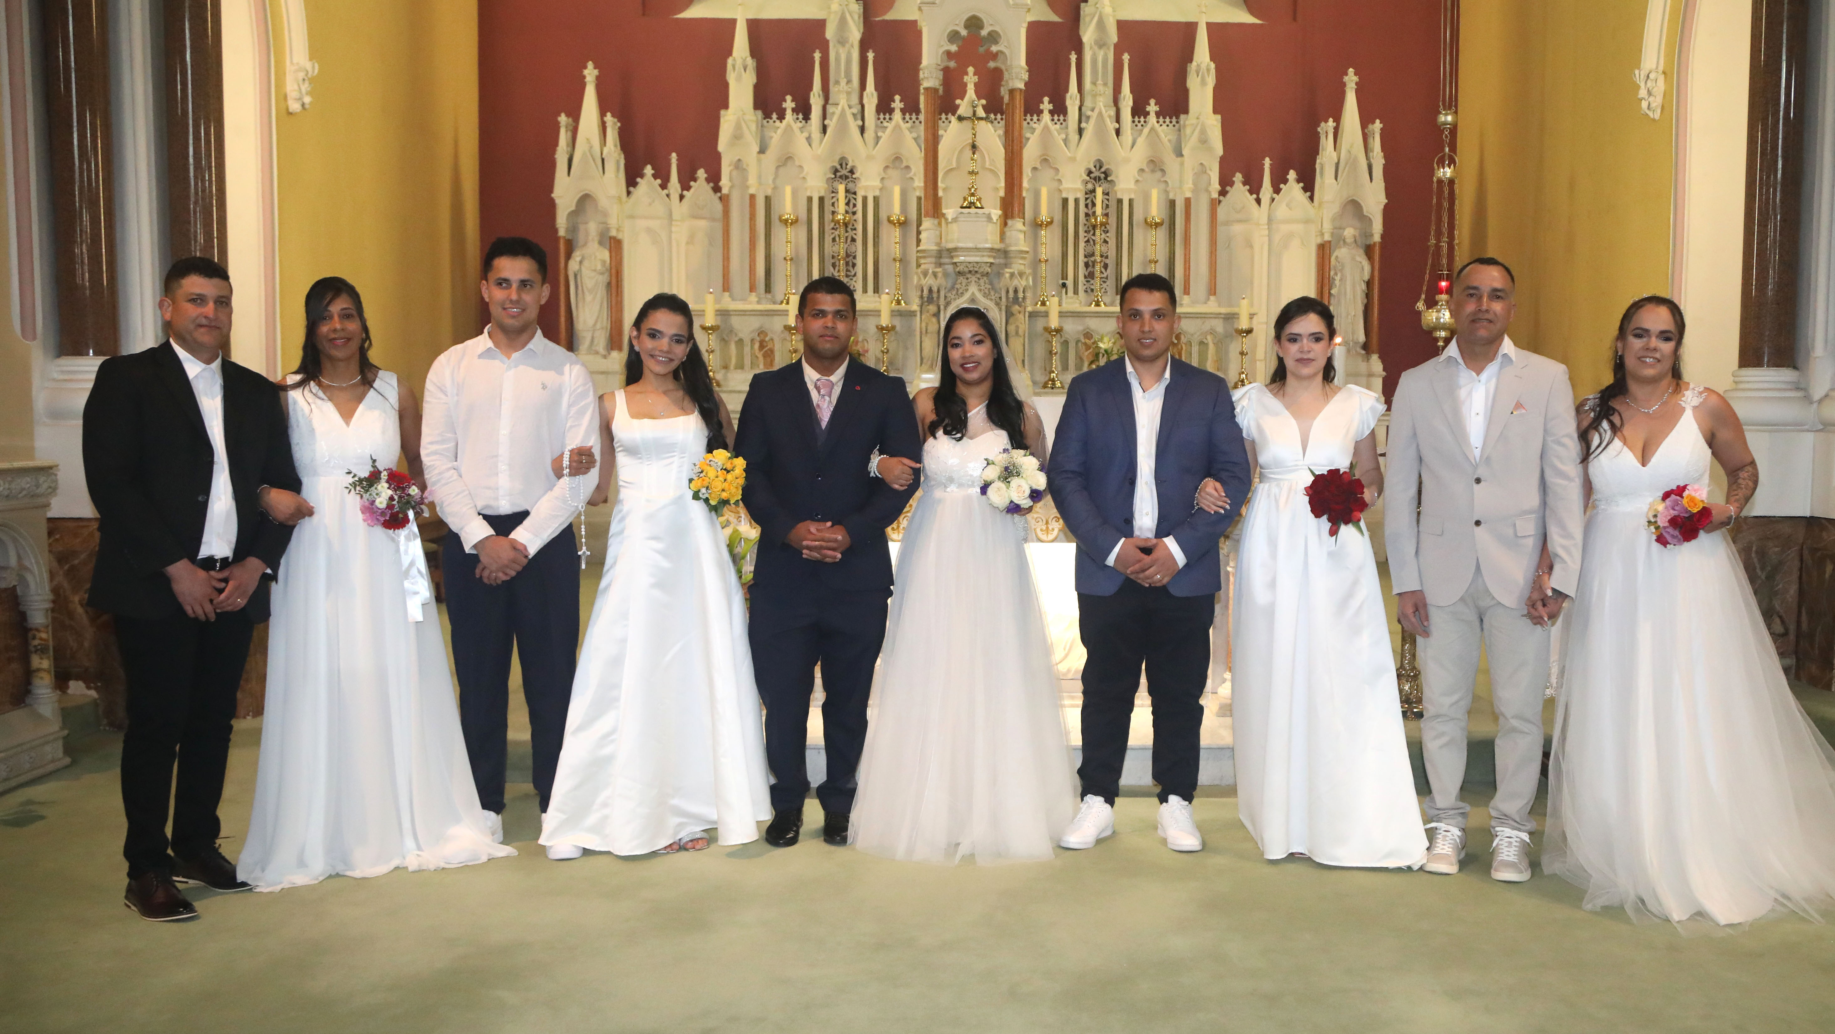

**Encounter: Moving from Welcome to Belonging**

Irish Catholic Bishops strongly encourage a “culture of encounter” that goes beyond mere tolerance of newcomers. Such a culture fosters authentic participation and integration. Polite tolerance can leave migrants feeling isolated, but true Christian encounter involves mutual enrichment, where established communities and newcomers share and learn from each other. It is noted that the Irish Council of Churches and the Irish Inter-Church Meeting, bodies which facilitate dialogue between all of the Churches across the island, have recently produced resources to help enhance such encounter and belonging. Pope Francis emphasises the need to engage with others deeply, not just seeing but truly listening and connecting with them. This spirit of encounter reflects the early Christian understanding that believers are ‘foreigners and exiles’ in the world, called to form connections beyond borders.

Our Church’s universality ensures that every parish is connected globally. Furthermore, Church teachings affirm the dignity of every person - including that of the migrant - and remind us that every person possesses inalienable rights and deserve respect and welcome.

***Reflect: When have you felt truly encountered, listened to, and valued? How did that impact you?***

**Challenges to Integration**

Immigration to Ireland is high at present, though not at the levels previously seen through the peak of the Celtic Tiger era. In the most recent year for which there are statistics (up to April 2024), 149,200 people came to live in Ireland. However, 69,900 people left Ireland in the same period[1]. The figures for Northern Ireland are lower, with the most recent statistics suggesting a net immigration of 2,300 people in 2022[2]. These numbers contain a great diversity. It includes Irish citizens returning to live here, people on employment visas coming to take up particular roles, EU citizens availing of the freedom of movement, people from Britain who benefit from the Common Travel Area and many others besides. A significant factor in the numbers coming to Ireland in recent years were Ukrainians who are fleeing the Russian invasion of February 2022. Their numbers constitute a net figure of just over 81,000[3]. The number of people who come seeking International Protection is a small proportion of the overall number – about 14,000[4]. According to the European Union statistics body, the number of people found to have been here in Ireland illegally in 2023 was 1,485 people[5].

One of the reasons why the topic of immigration can be contentious is that differences within the meaning of the term are not always acknowledged. “Immigrant” often means someone who has made a permanent home in a new country. “Migrant” often means someone who is only based in the new country for a period. “Asylum seeker” refers to someone who is claiming protection outside their country of origin, which is different from a “refugee”, who is someone who has had that claim confirmed. It is important to note that the formal definition of refugee does not include anybody displaced within their own country, or who travels abroad to escape poverty or famine.

While these definitions are important from a legal perspective, we should not allow them to obscure what matters most to Christians: regardless of where a person was born or what passport they carry: they are our neighbour.

An example of the challenges to integration is Patrick’s story. Patrick was born in Nigeria and grew up in a loving Catholic home before marrying and coming to work in Ireland in 2002. He tells us that adjusting to Irish society was challenging but he and his family gradually integrated ‘through a long process of acculturation’. He adds, ‘we have four children, all born in Ireland, who identify more as Irish than Nigerian. After my wife’s passing, we navigated through difficult times but also enjoyed good moments together. Finding employment was a difficult challenge but I got help and training through State sponsored FÁS courses and I am now in my third and, hopefully, most lasting job.’ While Patrick is aware of the cultural differences he has experienced in work, in Church and with neighbours, he concludes that despite all of this, ‘coming to Ireland has been a blessing. We have the freedom to practice our faith and we are happy, although we miss Nigeria and find travel there expensive.’

It is common to hear people talk about the costs of immigration. But almost one-in-five workers in the Irish economy are ‘non-Irish-nationals’[6]. Our economy could not function without the people working in the sectors of hospitality, education, healthcare and technology, who have come here from elsewhere. Economists describe our economy as “at full employment” and it is still growing. There is clearly an inescapable need for migration. No one can but doubt that these newcomers have become foundational to the positive operation of our society.

***Reflect: How have migrants blessed your life?***

**Building a Friendly Society**

Ireland faces significant challenges, such as homelessness, strained health services, and an education system struggling to meet demands. However, these issues have been on the landscape for some time - they have not been caused by migration.

Migrants can help address these needs, contributing positively to society. It is important to approach immigration policies in a way that serves the common good, which includes both migrants and citizens. We are fortunate to live in a country with a stable democracy and a vibrant civil society, and we encourage all citizens to participate in such political debate to the fullest of their abilities and convictions.

Pope Francis urges political leaders to prioritise effective solutions to social and economic exclusion, emphasising “political charity” to overcome individualism. Christians are called to support this vision collectively.

***Reflect: How can you encourage constructive debate on the things that really matter in our society?***

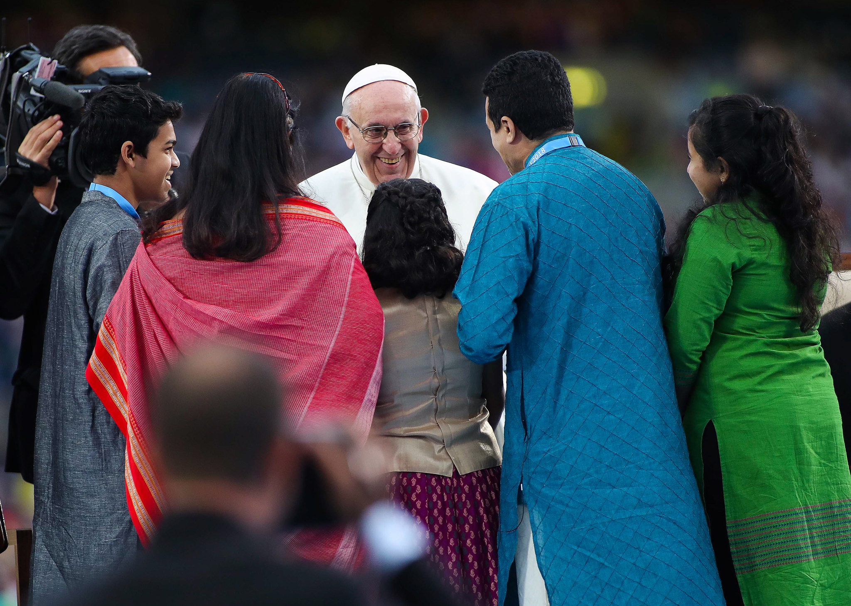

**Caption** Pope Francis greets pilgrims in Croke Park, Dublin, during the Holy Father’s visit to Ireland for the 9th World Meeting of Families in August 2018.

**A Call to Parishes: Community Sponsored Programme**

As Irish society changes, the Church is tasked with welcoming and integrating migrants. Pope Francis warns against building “walls in the heart” and encourages a culture of openness, reflecting Jesus’ inclusive ministry and his command ‘Ephphatha’ – be opened! *(Mark 7:31-37).* Parishes are urged to oppose fear and recognise the image of God *(Genesis 1:27)* in every migrant, regardless of nationality.

One practical response is the Community Sponsorship Programme, where local communities sponsor and resettle refugee families. This scheme is supported by the Government of Ireland and led by the Irish Red Cross and partners. One example of this is the parish of Clane in Co Kildare, which successfully welcomed a Syrian family in 2019, and it provides a model for how parishes can respond to refugee needs with hospitality and support[7].

***Reflect: How can migrants in your parish help shape the journey from welcome to belonging?***

**Conclusion**

Migration presents many challenges for all involved: immigrants seeking safety and a better future, as well as for those who welcome them, and the governments and communities responsible for providing shelter and support.

As migration to Ireland increases, it brings both difficulties and opportunities for society. While the changes ahead remain uncertain, the teachings of the Gospel provide timeless guidance on addressing these challenges.

Catholic Social Teaching emphasises the dignity of every human being and the common good, offering a foundation for action. The Church sees the “travail of migrants” as a violation of human dignity, and urges us to welcome migrants so as to support the defence of their inalienable rights[8].

The patron saints of immigrants and refugees, such as Saint Patrick, Saint Frances Xavier Cabrini and Saint Josephine Bakhita, remind us of the Christian call to compassion, love, and service to the marginalised. As we face the ongoing realities of migration, displacement, and human trafficking, we must draw from these sources of faith for guidance.

May we always welcome and advocate for migrants. In doing so, we fulfil our shared role as a “migrant pilgrim people,” continuing the Irish tradition of openness, encounter, and hospitality, and bearing witness to God’s eternal love.

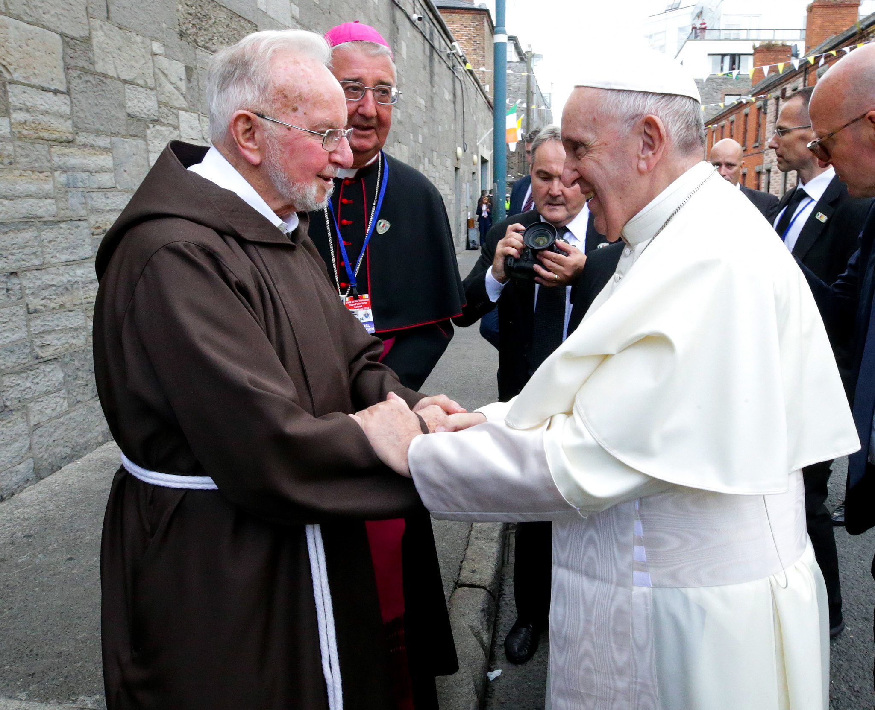

**Caption** Brother Kevin Crowley OFM Cap as CEO of the Capuchin Day Centre, and Archbishop Diarmuid Martin of Dublin, greet Pope Francis during the Holy Father’s visit to Ireland for the 9th World Meeting of Families in August 2018.

______________________________________

**Front page caption** Pope Francis with the sculpture ‘Angels Unawares’ by Timothy Schmalz, which was installed in September 2019 in Saint Peter's Square, Vatican City, to mark the 105th World Migrant and Refugee Day. Permission for publication has been granted to the Catholic Communications Office by Timothy Schmalz.

All other images have been sourced from the Catholic Communications Office archive.

_____________________________

**This Pastoral Letter has been designed by the CCO and reproduction is welcome. Please credit as the source:** **The Irish Catholic Bishops’ Conference. For further information email info@catholicbishops.ie**

1. Central Statistics Office (CSO), ‘Population and Migration Estimates, April 2024’, [Key Findings Population and Migration Estimates, April 2024 - Central Statistics Office](https://www.cso.ie/en/releasesandpublications/ep/p-pme/populationandmigrationestimatesapril2024/keyfindings/#:~:text=Net%2520migration%2520rises%2520in%2520the,2023%2520and%252051%252C700%2520in%25202022.) 
2. Hayley Halpin, “How much immigration is there in Northern Ireland?”, BBC News, August 11, 2024, https://www.bbc.com/news/articles/cgm7vn2kegjo In Northern Ireland, where the arrangements are different because they are not members of the European Union, the number of Ukrainians increased by just over 1,000, totalling 3,149 people in the most recent statistics. Kurtis Reid, “Refugees on missing their homeland two years after start of war: ‘I’m very grateful to the people here’.” Belfast Telegraph, February 24, 2024. <https://www.belfasttelegraph.co.uk/news/northern-ireland/refugees-on-missing-their-homeland-two-years-after-start-of-war-im-very-grateful-to-the-people-here/a15315517.html>
3. According to the Central Statistics Office (CSO), up to 2 June 2024, 107,406 people arrived in Ireland from Ukraine under the Temporary Protection Directive. Of these, some 76% had ‘administrative data’ after 31 March 2024. See, [Arrivals from Ukraine in Ireland Series 13 - Central Statistics Office](https://www.cso.ie/en/releasesandpublications/fp/p-aui/arrivalsfromukraineinirelandseries13/#:~:text=There%2520were%2520107%252C406%2520Personal%2520Public,in%2520the%2520previous%2520seven%2520days.)

  
4. International Protection Office (IPO), ‘Monthly Statistical Report, August 2024’, [20240910 IPO Website Stats Aug 2024 FINAL.pd](https://www.ipo.gov.ie/en/IPO/20240910%20IPO%20Website%20Stats%20Aug%202024%20FINAL.pdf/Files/20240910%20IPO%20Website%20Stats%20Aug%202024%20FINAL.pdf)f
5. Eurostat, ‘Third country nationals found to be illegally present – annual data’ [Statistics | Eurostat (europa.eu)](https://ec.europa.eu/eurostat/databrowser/view/migr_eipre/default/table?lang=en) 
6. Tom Healy, “The Benefits and Costs of Immigration in Ireland,” Slí Chaol (blog), April 4, 2024, [https://slichaol.blogspot.com/2024/04/the-benefits-and-costs-of-immigration.html.](https://slichaol.blogspot.com/2024/04/the-benefits-and-costs-of-immigration.html)
7. [For further information, visit Community Sponsorship Ireland - Irish Red Cross](https://www.redcross.ie/community-sponsorship-ireland/) <https://www.redcross.ie/community-sponsorship-ireland/>
8. Dicastery for the Doctrine of the Faith, Dignitas Infinita: Declaration on Human Dignity (Rome: Libreria Editrice Vaticana, 2024), §40.